**Practical 9: Implementation of Tree and Searching**

Name: Sutariya Savankumar

Roll no: MA065

1. **Write a program to do the following operations.**

**● Create a Binary Tree by collecting information from users.**

**● Create a Binary Search Tree by collecting information from users.**

**● Traverse the created trees using**

**○ preorder**

**○ postorder**

**○ inorder**

**○ levelorder**

**● Search Element in Binary Search Tree**

**● Find Internal Nodes, External Nodes, Total Nodes and Height of Tree**

Code

#include <stdio.h>

#include <stdlib.h>

struct Node

{

    int data;

    struct Node *left;

    struct Node *right;

};

struct Node *create(int data)

{

    struct Node *newNode = (struct Node *)malloc(sizeof(struct Node));

    newNode->data = data;

    newNode->left = NULL;

    newNode->right = NULL;

    return newNode;

}

struct Node *insertNode(struct Node *root, int data)

{

    if (root == NULL)

    {

        return create(data);

    }

    if (data < root->data)

    {

        root->left = insertNode(root->left, data);

    }

    else if (data > root->data)

    {

        root->right = insertNode(root->right, data);

    }

    return root;

}

struct Node *createBinaryTree()

{

    int data;

    struct Node *root = NULL;

    printf("Enter root node data: ");

    scanf("%d", &data);

    root = create(data);

    printf("Enter left child of %d : ", data);

    scanf("%d", &data);

    if (data != -1)

    {

        root->left = create(data);

        printf("Enter left child of %d : ", root->left->data);

        scanf("%d", &data);

        if (data != -1)

        {

            root->left->left = create(data);

        }

        printf("Enter right child of %d : ", root->left->data);

        scanf("%d", &data);

        if (data != -1)

        {

            root->left->right = create(data);

        }

    }

    printf("Enter right child of %d : ", data);

    scanf("%d", &data);

    if (data != -1)

    {

        root->right = create(data);

        printf("Enter left child of %d : ", root->right->data);

        scanf("%d", &data);

        if (data != -1)

        {

            root->right->left = create(data);

        }

        printf("Enter right child of %d : ", root->right->data);

        scanf("%d", &data);

        if (data != -1)

        {

            root->right->right = create(data);

        }

    }

    return root;

}

void preorder(struct Node *root)

{

    if (root == NULL)

        return;

    printf("%d ", root->data);

    preorder(root->left);

    preorder(root->right);

}

void inorder(struct Node *root)

{

    if (root == NULL)

        return;

    inorder(root->left);

    printf("%d ", root->data);

    inorder(root->right);

}

void postorder(struct Node *root)

{

    if (root == NULL)

        return;

    postorder(root->left);

    postorder(root->right);

    printf("%d ", root->data);

}

void levelorderTraversal(struct Node *root)

{

    if (root == NULL)

        return;

    struct Node **queue = (struct Node **)malloc(sizeof(struct Node *) * 100);

    int front = -1;

    int rear = -1;

    queue[++rear] = root;

    while (front < rear)

    {

        struct Node *node = queue[++front];

        printf("%d ", node->data);

        if (node->left != NULL)

            queue[++rear] = node->left;

        if (node->right != NULL)

            queue[++rear] = node->right;

    }

}

struct Node *search(struct Node *root, int key)

{

    if (root == NULL || root->data == key)

        return root;

    if (root->data < key)

        return search(root->right, key);

    else

        return search(root->left, key);

}

void countNodesAndHeight(struct Node *root, int *internalNodes, int *externalNodes, int *totalNodes, int *height)

{

    if (root == NULL)

        return;

    (*totalNodes)++;

    if (root->left == NULL && root->right == NULL)

        (*externalNodes)++;

    else

        (*internalNodes)++;

    int leftHeight = 0;

    int rightHeight = 0;

    countNodesAndHeight(root->left, internalNodes, externalNodes, totalNodes, &leftHeight);

    countNodesAndHeight(root->right, internalNodes, externalNodes, totalNodes, &rightHeight);

    *height = (leftHeight > rightHeight ? leftHeight : rightHeight) + 1;

}

int main()

{

    struct Node *root = NULL;

    int choice, data, key, internalNodes = 0, externalNodes = 0, totalNodes = 0, height = 0;

    do

    {

        printf("\n--- Binary Tree and Binary Search Tree Operations ---\n");

        printf("1. Create Binary Tree\n");

        printf("2. Create Binary Search Tree\n");

        printf("3. Preorder Traversal\n");

        printf("4. Inorder Traversal\n");

        printf("5. Postorder Traversal\n");

        printf("6. Levelorder Traversal\n");

        printf("7. Search Element in Binary Search Tree\n");

        printf("8. Count Internal Nodes, External Nodes, Total Nodes, and Height of Tree\n");

        printf("9. Exit\n");

        printf("Enter your choice: ");

        scanf("%d", &choice);

        switch (choice)

        {

        case 1:

            root = createBinaryTree();

            break;

        case 2:

            printf("Enter root node data: ");

            scanf("%d", &data);

            root = create(data);

            while (1)

            {

                printf("Enter data to be inserted : in stop then -1 ");

                scanf("%d", &data);

                if (data == -1)

                    break;

                insertNode(root, data);

            }

            break;

        case 3:

            printf("Preorder Traversal: ");

            preorder(root);

            break;

        case 4:

            printf("Inorder Traversal: ");

            inorder(root);

            break;

        case 5:

            printf("Postorder Traversal: ");

            postorder(root);

            break;

        case 6:

            printf("Levelorder Traversal: ");

            levelorderTraversal(root);

            break;

        case 7:

            printf("Enter element to search: ");

            scanf("%d", &key);

            if (search(root, key) != NULL)

                printf("Element found in the tree.\n");

            else

                printf("Element not found in the tree.\n");

            break;

        case 8:

            countNodesAndHeight(root, &internalNodes, &externalNodes, &totalNodes, &height);

            printf("Total number of nodes in the tree: %d\n", totalNodes);

            printf("Number of internal nodes in the tree: %d\n", internalNodes);

            printf("Number of external nodes in the tree: %d\n", externalNodes);

            printf("Height of the tree: %d\n", height);

            break;

        case 9:

            printf("Exiting...\n");

            exit(0);

        default:

            printf("Invalid choice!\n");

            exit(0);

            break;

        }

    } while (choice != 9);

    return 0;

}

Output

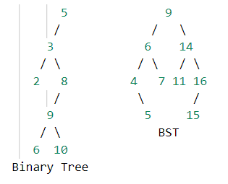

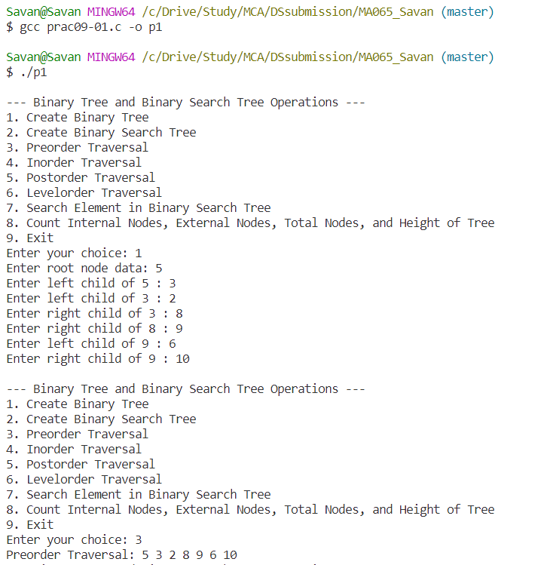

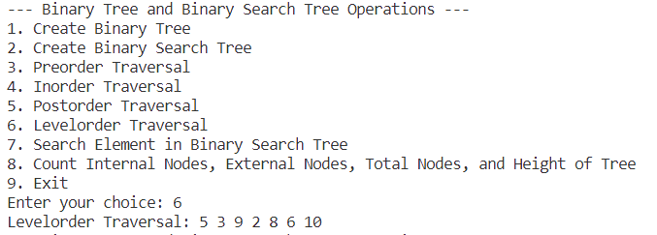

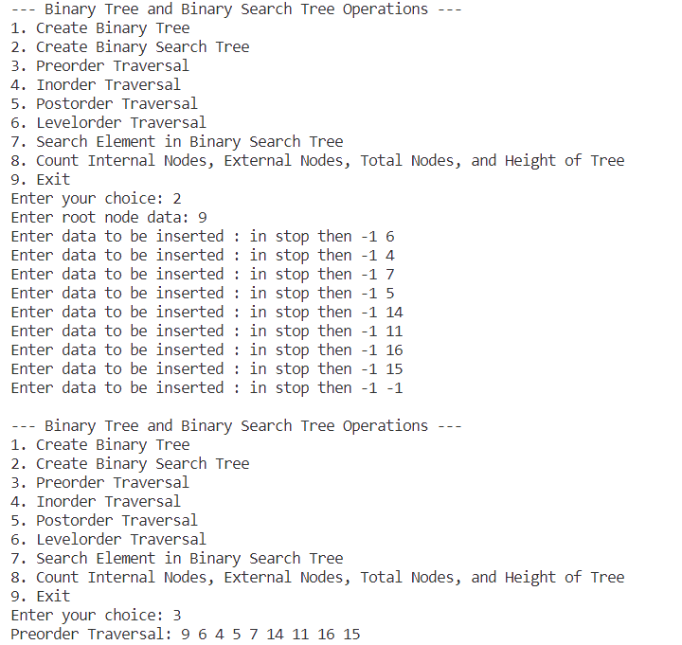

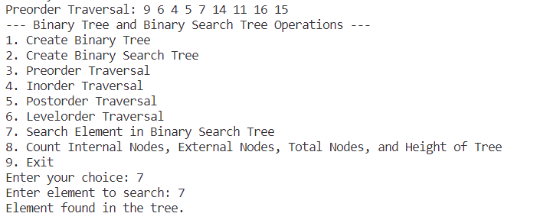

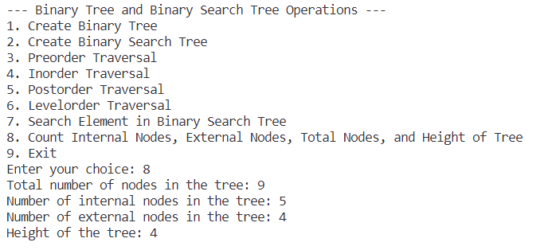

1. **Write a program to do the following operations.**

**● Create an array from user input.**

**● Search Element in an array using linear search - prints iteration done to find the**

**element**

**● Search Element in an array using binary search - prints iteration done to find**

**the element**

Code

#include <stdio.h>

int LinearSearch(int arr[], int size, int key)

{

    for (int i = 0; i < size; i++)

    {

        if (arr[i] == key)

            return i;

    }

    return -1;

}

int BinarySearch(int arr[], int size, int key)

{

    int start = 0;

    int end = size - 1;

    while (start <= end)

    {

        int mid = start + (end - start) / 2;

        if (arr[mid] == key)

            return mid;

        else if (arr[mid] > key)

            end = mid - 1;

        else

            start = mid + 1;

    }

    return start;

}

int main()

{

    int size;

    printf("Enter the size of the array: ");

    scanf("%d", &size);

    int arr[size];

    printf("Enter the elements of the array: ");

    for (int i = 0; i < size; i++)

        scanf("%d", &arr[i]);

    int key;

    printf("Enter the element to be searched: ");

    scanf("%d", &key);

    printf("\nLinear Search\n");

    int index = LinearSearch(arr, size, key);

    if (index == -1)

        printf("Element not found in the array");

    else

        printf("Element found at index %d", index);

    printf("\nBinary Search\n");

    index = BinarySearch(arr, size, key);

    if (index == -1)

        printf("Element not found in the array");

    else

        printf("Element found at index %d", index);

    return 0;

}

Output

